5.46: a) The analysis of Example 5.22 may be used to obtain 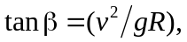 but the subsequent algebra expressing R in terms of L is not valid. Denoting the length of the horizontal arm as r and the length of the cable as 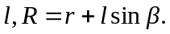 The relation 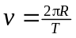 is still valid, so 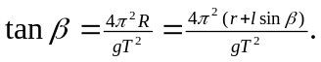 Solving for the period T,
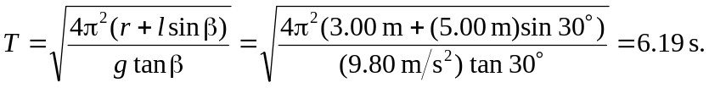
Note that in the analysis of Example 5.22, is the angle that the support (string or cable) makes with the vertical (see Figure 5.30(b)). b) To the extent that the cable can be considered massless, the angle will be independent of the rider’s weight. The tension in the cable will depend on the rider’s mass.

